This is an analog clock which has maximum time count of 60 seconds.

For simplicity the green light of the clock rotates once in a second

And the red light rotates once in a minute.

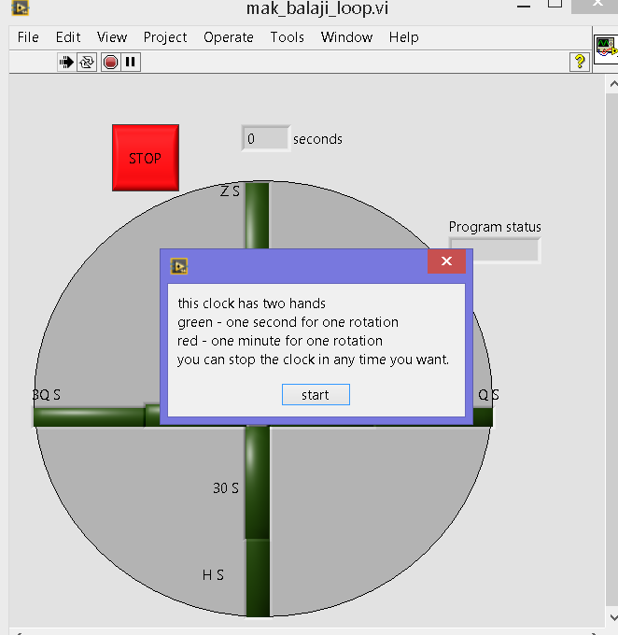

When we run this program a window pops and tells user about the clocks characteristics.

If the user clicks the start button, then it starts its counting process.

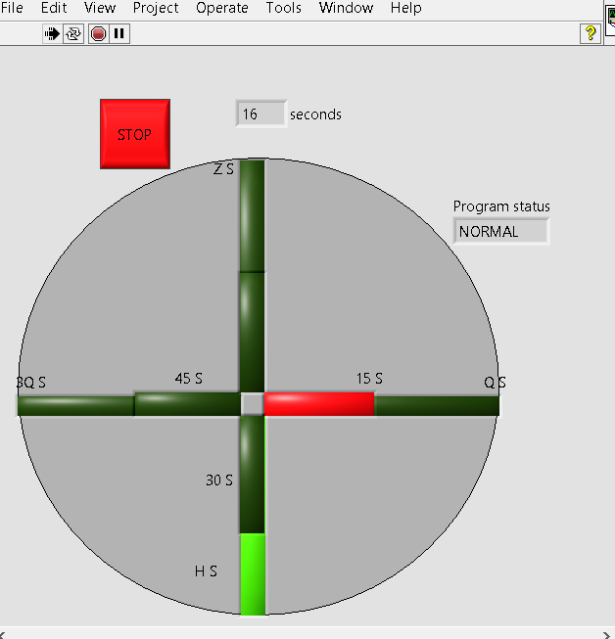

If the limit exceeds then clock stops itself and changes its status to OVERFLOW.

The user can stop the clock in between itself by pressing the STOP button

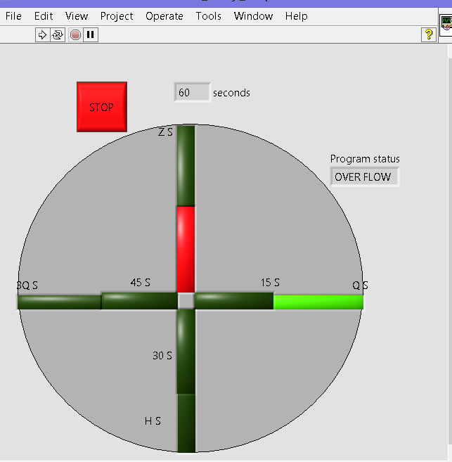

I have used a subVI which converts a indexed decimal number in an array to Boolean collection.

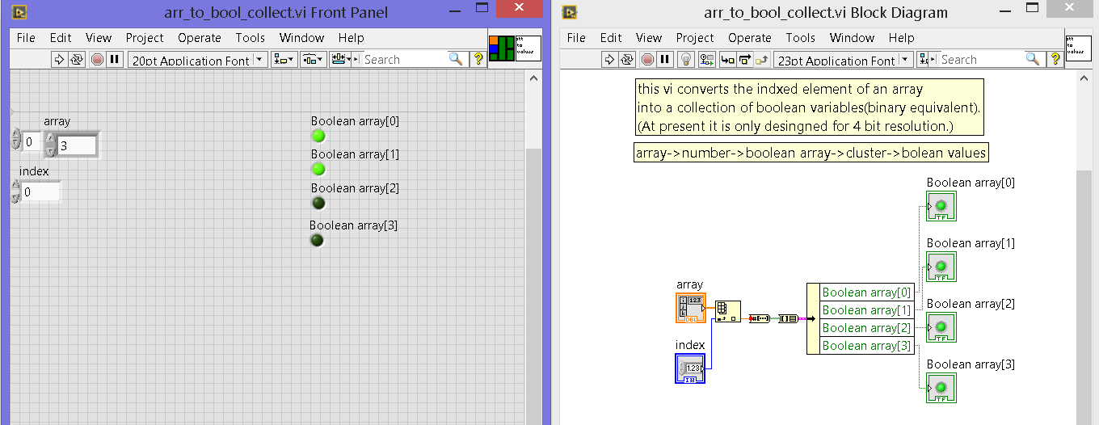

It has two inputs (array & array index)

And Boolean outputs.